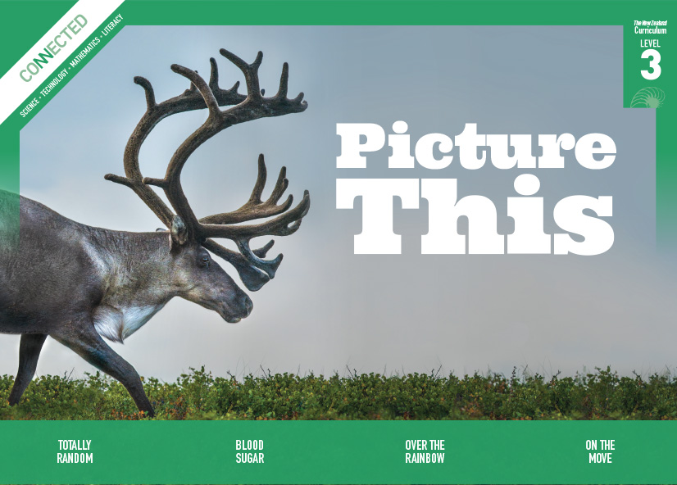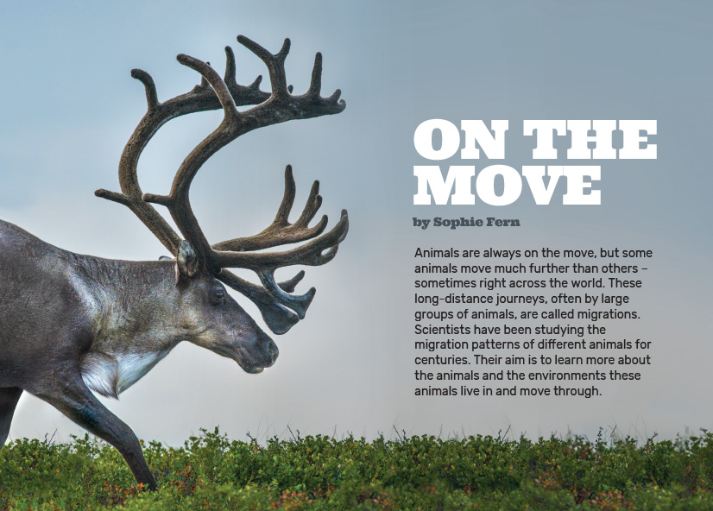
Connected
Level 3
2016

On the Move
by Sophie Fern

Overview
This article describes the migratory patterns of a variety of different animal species, including humans. It explains how and why scientists study these patterns and what they have learnt from their research.
A Google Slides version of this article is available at www.connected.tki.org.nz. This text also has additional digital content, which is available online at www.connected.tki.org.nz.

Curriculum contexts

SCIENCE: Nature of Science: Communicating in science  Level 3 – Begin to use a range of scientific symbols, conventions, and vocabulary. | Key Nature of Science ideas  Scientists:  - make observations and gather data in all kinds of ways to help them understand the world around them  - communicate their ideas in a variety of ways  - use graphs, diagrams, and maps to present data gathered from scientific investigations.
SCIENCE: Living World: Ecology  Level 3 – Explain how living things are suited to their particular habitat and how they respond to environmental changes, both natural and human-induced. | Key science ideas  - Habitats can be affected by natural phenomena and humans.  - Living things sense the world around them in different ways and respond to the sensory information in ways that help them to survive.  - Living things sometimes migrate over very large distances to find food, water, or shelter.
ENGLISH: Reading  Level 3 – Ideas: Students will show a developing understanding of ideas within, across, and beyond texts. | Indicators  - Uses their personal experience and world and literacy knowledge confidently to make meaning from texts.  - Makes meaning of increasingly complex texts by identifying main and subsidiary ideas in them.  - Starts to make connections by thinking about underlying ideas in and between texts.  - Makes and supports inferences from texts with increasing independence.

The New Zealand Curriculum

Science capability: interpret representations

Capability overview
Scientists represent their ideas in a variety of ways. They might use models, graphs, charts, diagrams, photographs, and written text. A model is a representation of an idea, an object, a process, or a system. Scientists often use models when something is not directly observable. Models enable scientists to work on their ideas, even though they are often using a limited representation of the “thing” itself. It is important students can identify what is the same and what is different about the model and the thing. | It is important for students to think about how data is presented and ask questions such as:  - What does this representation tell us?  - What is left out?  - How does this representation get the message across?  - Why is it presented in this particular way?  This sort of questioning provides a foundation to critically interact with ideas about science in the media and to participate as critical, informed, and responsible citizens in a society where science plays a significant role.

More about the capability

The capability in action
The science capability “Interpret representations” is about students understanding information that is presented as a description or in visual form and recognising the best way to present information.  Scientific representations include diagrams, models, charts, and graphs, as well as written text.  Scientists develop models and diagrams that best represent their theories and explanations.  Scientists  Scientists use:  - representations that can help both the original scientist and others clarify, critique, and evaluate their ideas, research, and theories  - computer and other kinds of modelling to predict what might happen in certain conditions and then test these predictions to see how accurate the model or idea is  - diagrams or models to communicate science ideas  - graphs to present data  - scientific forms of text involving argumentation that use evidence to debate explanations.  Students  Students should have opportunities to:  - learn to interpret a variety of representations, including models, diagrams, graphs, and text  - develop their own representations of scientific ideas, for example, through modelling using concrete materials or using their own bodies in mime and drama  - recognise how the model or representation matches the science idea and how it is different  - consider and critique a range of representations, including scientific texts, newspaper articles about scientific matters, online information about science matters, and scientific representations developed by their peers. | Teachers  Teachers can:  - help students to be more critical consumers of science information by being explicitly critical themselves and modelling useful questions  - support students to evaluate how information is presented, for example, to assess if a graphical representation has been done appropriately or is it misleading  - ask questions such as:  - What do you think this representation tells us?  - What do the (arrows, lines, symbols, etc.) mean? (that is, help your students interpret the features)  - Is anything left out? Do you think anything is missing?  - How does this get the message across?  - Is there anything more you need to know to be able to interpret this representation?  - How does the representation make the science idea clear?  - Which aspects of this representation could mislead the reader?  - Why is it presented in this way?  - Could you suggest a better way to represent it?  - establish a science classroom culture by:  - modelling and encouraging a critical stance  - encouraging students to consider the quality and interpretation of scientific representations  - introducing learning conversations that involve interpreting, critiquing, and developing representations to demonstrate the idea's relevance in everyday life.

More activities to develop the capability

Meeting the literacy challenges

The literacy demands lie in the use of maps, diagrams, and photos to represent a wide range of information. The maps illustrate information found in the text, but the arrows and colours identify patterns of migration.  Students will need to infer that the diagram on page 28 is stylistic and that they can use it to connect the information with what’s written in the text to support their understanding of how animals are tracked using satellite technology. | The following strategies will support students to understand, respond to, and think critically about the information and ideas.  You may wish to use shared or guided reading, or a mixture of both, depending on your students’ reading expertise and their background knowledge.  After reading the text, support students to explore the activities outlined in the following pages.

INSTRUCTIONAL STRATEGIES

Finding the main ideas  TELL the students the title and provide a brief introduction. Note that “On the Move” is an idiomatic expression that may not be familiar to English language learners. (The expressions “spotted” and “keep your eyes peeled” on page 25 may also require explanation.)  Have the students read the first paragraph. ASK QUESTIONS to prompt them to make connections to what they know about migration and to predict the author’s purpose.  What is the key word in this paragraph?  What animals migrate?  What do you think the term “migration patterns” means?  What do you think the author wants us to learn from this article?  What might scientists learn from studying animals’ migration patterns?  Based on this discussion, ask the students to suggest what might be covered in this article. (These might include frequency of migration, route, reason for migrating, ways of tracking an animal’s migration, and what scientists have learnt from tracking animal migrations.) RECORD the students’ ideas on the whiteboard.  DISCUSS any other topics that should be added to the students’ list and any topics that were on the students’ list but are not in the article, as well as anything they would like to learn about animal migration.  Using maps, diagrams, and visual features to gain deeper understanding  PROMPT the students to look closely at the map on page 25. Discuss the places listed on the map and encourage them to read the text carefully and make connections between the map and the text.  How much of the world can you see in this map? (Help them to recognise that this map is a section of the Southern Hemisphere and have a typical map on hand for comparison.)  What is this map showing us?  Show me where the southern right whales are based during winter and early spring. Can you remember what they are doing at that time? | Where do they go for summer? What does the text tell you about why they migrate?  Show me the coast of mainland New Zealand. Why might you see southern right whales there in spring and autumn?  What do the different coloured arrows show?  What is missing that you might expect to see on a map? How can we know what this map is showing when it has no title, compass, or key?  ASK QUESTIONS to help the students understand what they can learn from the diagram on page 26, which shows the life cycle of a longfin eel (known as tuna in Māori).  What does the diagram represent?  How does it show the different types of water the eel spends time in?  How can you tell the direction of this life cycle?.  What is different about the egg stage and the other stages in a longfin eel's life cycle? (In the egg stage, new creatures are being born. In the other stages, the same animal is changing its form.)  When the students read the breakout text “Knowing When to Go” on page 27, CHECK their understanding by having them complete the following diagram:  Cues for migration  Internal cues may include:  External cues may include:  Encourage the students to add further examples of internal or external cues for migration that they read about in this text, know about already, or learn about after the reading. These could include their responses to the author’s final question about why humans migrate today.

Meeting the literacy challenges

Look at the photograph of the shining cuckoo on page 27. DISCUSS the significance of the scientific knowledge supplied in the photo’s caption and the cultural knowledge supplied in the whakataukī. Both kinds of knowledge arise from observing patterns in nature.  ASK the students to study the diagram of satellite tracking on page 28.  What kinds of technology are being used in this diagram?  How does this diagram help you understand the text?  Why might scientists want to know the data about temperature, wind speed, or rainfall?  The migration pattern of the monarch butterfly is quite complex as it models how four generations of butterfly complete the migration. PROMPT the students to look closely at the map and the diagram of the seasons on page 30.  What is the purpose of the diagram? What do the different colours mean? How is this diagram different from the diagram for the longfin eel?  What part of the world can you see in this map?  What is the relationship between the diagram and the map? (Help the students to notice that the colours in the diagram work as a key for the times of year shown in the map. If necessary, prompt the students further by asking, What do you notice about how the colours are used on the map and in the diagram?)  What are the two main areas where the butterflies like to spend winter?  Look at the different migratory paths. Which group of butterflies has the shortest migration (the group that migrates between Canada and California) and which has the longest migration (the group that migrates between Canada and Mexico)?  PROMPT the students to think of questions they could ask their classmates that would test their ability to read the text and analyse the diagram and map. Give them time to ask and answer each other's questions in pairs or small groups. | MODEL how you can use the map on page 32 to trace what you imagine your own family’s migration to be. EXPLAIN that you can’t be certain without doing genetic testing, but that this is your best guess. Also explain that our understanding of when and where human migrations first took place is changing as archaeologists (scientists who study the history of humans) discover more ancient bones and artefacts around the world.  I am Pākehā on my mother’s side and Māori on my father’s side. My ancestors on both sides of my family originated somewhere in Africa 150,000 to 100,000 years ago. They moved north and reached the part of the world we now call the Middle East 100,000 to 70,000 years ago. That’s where they split up. My mother’s ancestors eventually arrived in northern Europe 35,000 years ago. Then, 120 years ago, they migrated to New Zealand, looking for better opportunities.  Dad’s side of the family migrated across what is now Middle East and Asia and eventually moved down through the Pacific islands. The map says that they reached the Pacific 3,000 to 2,000 years ago. My Māori ancestors then migrated from the Pacific to New Zealand 1,000 years ago. I guess they were the same as my Pākehā ancestors – looking for a better life for them and their children.  Encourage the students to make connections to their own lives by identifying the parts of the world they believe they or their ancestors have migrated from and tracing this on the map. They can share this with a partner.  DISCUSS the significance of the date ranges being written from the longest time ago to the most recent. Does it seem odd to see the date ranges written as 35,000 to 25,000 years ago rather than 25,000 to 35,000 years ago? Why do you think the dates have been shown in this order?

Reading standard: by the end of year 6
The Literacy Learning Progressions
Effective Literacy Practice: years 5–8

Meeting the literacy challenges

TEACHER SUPPORT
Living things sometimes migrate over very large distances to find food, water, or shelter.  The illustration represents the scientific process described in the text. | 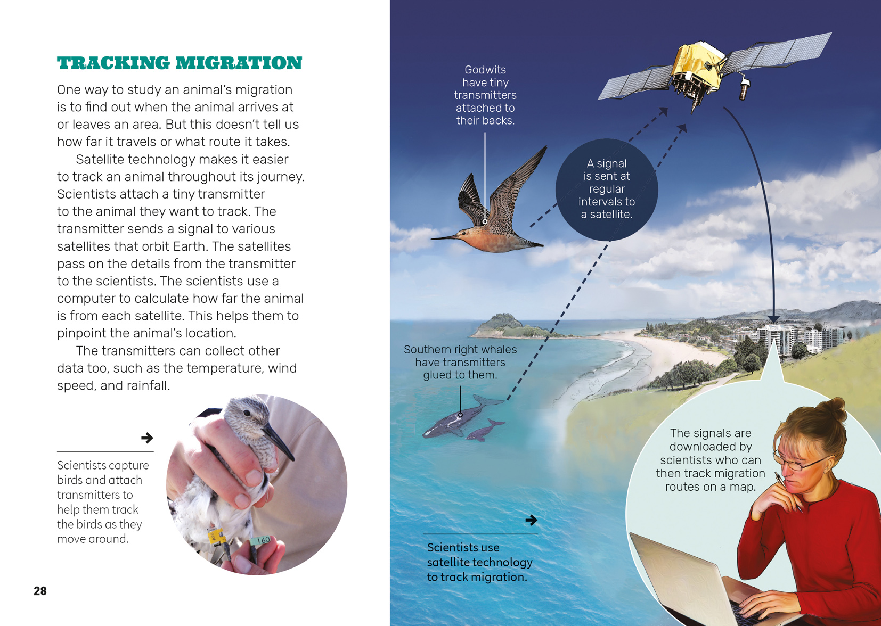  Scientists make observations and gather data in all kinds of ways to help them understand the world around them.

Learning activities – Exploring the science
The following activities are a guide for supporting students to explore and understand the science capability “interpret representations”. Some activities focus directly on the science capability. Other activities extend students’ content knowledge across the learning areas. Adapt these activities to support your students’ learning needs.

Activity 1 – Reporting on migration
Ask the groups to look again at the list of topics covered in the article that they created earlier (see the literacy section above). Have them review the ways the author communicated the information and how well this worked. Record their comments in order to put together a set of criteria for writing an engaging report on animal migration.
What did you think of the author’s writing style? Did she get your attention? How did she do that?
What did you think of the content? Were you able to find all the information you wanted? Were there gaps where you wanted to know more?
What did you notice about the structure of the article? Was there a clear introduction and conclusion? Was the information in the right order? Did the headings help you to understand what each section of text was going to be about?
Look at the way migration is represented in each of the diagrams. What is similar and what is different about these diagrams? Is there a diagram that you think is particularly clear? What made you choose that one?
Look at the diagram for the life cycle of the longfin eel. Would the same sort of diagram work for representing the life cycle of another animal you know about?
Why did the author include maps and photographs? What did they add to your understanding?
Based on this discussion, work with the students to finalise a set of criteria for writing a report on the migratory patterns of a particular animal.
Have the students explore other examples of birds or fish that migrate to or from New Zealand, such as kōkopu, godwits, or royal albatrosses (toroa). Each student can carry out research into one of these, finding out where the animal migrates to and what sorts of questions scientists have been asking about that animal. The students’ reports should include a diagram that shows the key features of their chosen animal’s migration. Assessment should be based on the criteria for writing reports that the students established earlier.

Activity 2: Taking action as citizen scientists
The students could investigate other programmes that involve scientists collecting and logging data on animals’ migratory patterns. They could read other articles, such as: “The Fish Highway” (Connected 2013, level 3, Food for Thought), “Gather Your Data” (Connected 2013, level 4, Are You Sure?), “Counting Kākahi” (Connected 2014, level 3, Why Is That?), and “The Past Beneath our Feet” (School Journal, May 2016, level 3). They could find out what scientists are learning from their research.
All these articles discuss the idea of “citizen scientists”, who help professional scientists with their research. Zooniverse is a website that allows people from all around the world to participate in a range of research, including monitoring the migration of wildebeest in Serengeti.
Give the students the opportunity to explore the website and see if there are any projects that capture their interest. They could get involved as citizen scientists and share what they learn about animal migration and behaviours with the rest of the class.

Learning activities – Exploring the science

RESOURCE LINKS

Building Science Concepts  Connected  “The Fish Highway”, Connected 2013, level 3, Food for Thought. https://docs.google.com/presentation/d/1mPkin62_zOxfuuGMb6wM_VhIKQC9TRFWo0VVBj8pigI/present#slide=id.p  “Gather Your Data”, Connected 2013, level 4, Are You Sure? https://docs.google.com/presentation/d/1X8lQqJZGLkKgnhm-XRU1WwCi8jcUzsFKaYQDJbHwuBc/present?slide=id.p  “Counting Kākahi”, Connected 2014, level 3, Why Is That? https://docs.google.com/presentation/d/1p2N4x0txtY6FGegqoqpzuL1a86TlRsIalfMqQZYQnUQ/present?slide=id.p#slide=id.p  School Journal  “Pacific Paradise?” School Journal 4.2.2010  “The Past Beneath our Feet”, School Journal May 2016, level 3  Science Learning Hub  Student activity: Tracking E7 (bar-tailed godwit): http://link.sciencelearn.org.nz/resources/316-tracking-e7  Flight of the godwit (includes a map): http://link.sciencelearn.org.nz/resources/296-flight-of-the-godwit  Migration: http://link.sciencelearn.org.nz/topics/migration  “Getting ready to go” (a 1.45-minute video explaining how you can tell when godwits are ready to migrate): http://link.sciencelearn.org.nz/videos/718-getting-ready-to-go  “The longest flight” (a 2-minute video describing the amazing discovery of the godwits long non-stop migration flight): http://link.sciencelearn.org.nz/videos/721-the-longest-flight  Longfin eels: http://link.sciencelearn.org.nz/resources/441-longfin-eels  Monarch butterflies: http://link.sciencelearn.org.nz/resources/511-monarch-butterflies  Student activity: Tagging monarch butterflies for science: http://link.sciencelearn.org.nz/resources/700-tagging-monarch-butterflies-for-science | Other sources  Movebank: For animal tracking data (a free online database of animal tracking data): www.movebank.org  Safari Adventures: Migration Serengeti (Gnu/Wildebeest): http://safari-adventures.com/tanzania/migration-serengeti-8-days/?lang=en  Ducksters: Animal migrations: www.ducksters.com/animals/animal_migrations.php  LEARNZ: New Zealand Garden Bird Survey – Who’s in your backyard? (a virtual field trip that helps students discover how bird populations can change and what can cause such change): http://rata.learnz.org.nz/summary.php?vft=gardenbirdsurvey162  Te Papa: The flight of the godwit – science express (a 12.30-minute audio from a public forum on the migration of the bar-tailed godwit, as part of Te Papa’s Science Express programme): http://channel.tepapa.govt.nz/audio/the-flight-of-the-godwit/  YouTube  Science Screen Report: The amazing red crab of Christmas Island (video): www.youtube.com/watch?v=LNKgh6TfWXo (2.34 minutes)  Citizen science  NatureWatchNZ: http://naturewatch.org.nz/  Zooniverse (people-powered research): www.zooniverse.org  Zooniverse penguin watch (citizen science): www.penguinwatch.org/ and  www.bbc.com/news/science-environment-35981212  Radio New Zealand: Nine to noon (Thursday, 13 August 2015), Citizen scientists helping with major research projects: www.radionz.co.nz/national/programmes/ninetonoon/audio/201766313/citizen-scientists-helping-with-major-research-projects  Journey North: A global study of wildlife migration and seasonal change: www.learner.org/jnorth/  Cat Tracker NZ: www.cattracker.nz  Discovery Circle: Cat Tracker: www.discoverycircle.org.au/projects/cat-tracker/  “Monarch Migration Mystery” National Geographic Society. (Article and images about the monarch butterfly migration): http://nationalgeographic.org/news/monarch-migration-mystery/  Te Ara: The encyclopedia of New Zealand. Bar-tailed godwits’ migration www.teara.govt.nz/en/bird-migration  Migration. Department of Conservation shorebird migration education kit: www.doc.govt.nz/Documents/getting-involved/students-and-teachers/field-trips-by-region/016-shorebird-kit-(migration).pdf

